Changes in drug pricing
DATA-3400 Data Visualization NARRATIVE

Name: Erin Petersen
Date: 4/14/25

Question / PURPOSE
I have lots of questions about prescription medications, the FDA approval process, and medication drug pricing. As a pharmacy technician I get to see firsthand how the price of drugs effects patients. I would like to know if drug prices in the US are going up, and if it is all categories of medication or all in general. I wonder if the drug prices in the US are increasing in general, and if one category is increasing more than the others.

AUDIENCE
My audience would most likely be drug manufacturing companies. They would be the ones that would be able to take this information and do something about it. Specifically in the drug manufacturing company I would maybe target the CEO or someone who has a say on pricing. These people care a lot about profit, but they also care about the patients and getting them the medications as well.
The benefits of my audience acting in the way I would like them to are that there is a possibility that drug prices could be steadied, or maybe even giving the patients a better understanding of why they are priced the way they are. The risks of them not are that the patients could get increasingly more upset with them, or they could lose customers.

Data
I did change my data source from part one. I was able to find a new data source that has a ton of different medications (about 2 million!) and lots of different information that I can look at including the current price per unit for each medication, and the previous price per medication. This can help me compare each kind of drug and also compare how the drugs are changing over time.
This is the data I plan on using: https://data.medicaid.gov/dataset/a217613c-12bc-5137-8b3a-ada0e4dad1ff#data-table
Field Name | Description & Notes
NDC Description | Identifies the drug name, strength, and dosage form of the drug product.
NDC | The National Drug Code (NDC) is a numerical code maintained by the FDA that includes the labeler code, product code, and package code. The NDC is an 11-digit code.
Old NADAC Per Unit | The National Average Drug Acquisition Cost per pricing unit from the previous NADAC reference file.
New NADAC Per Unit | The National Average Drug Acquisition Cost per pricing unit from the current NADAC reference file.
Classification for Rate Setting | Indicates whether the NDC was considered brand ('B') or generic ('G') for the NADAC rate calculation process. If the NDC was considered brand ('B') and approved under an Abbreviated New Drug Application (ANDA), the indicator is shown as ('B-ANDA'). NDCs approved as biosimilar products are considered brand ('B') and will be designated as ('B-BIO').
Percent Change | The difference between the New NADAC Per Unit and the Old NADAC Per Unit, divided by the Old NADAC Per Unit.
Primary Reason | Describes the primary reason for the NADAC Per Unit change, see explanation below for each reason:  • Survey Rate: The NADAC Per Unit has been updated using information from the most recently completed pharmacy survey.  • WAC Adjustment: The NADAC Per Unit has been updated to reflect changes in published pricing.  • Help Desk Adjustment: The NADAC Per Unit has been updated as a result of an inquiry to the help desk.  • Brand Generic Change: The NADAC Per Unit has been updated as a result of a change in the Classification for Rate Setting.  • Rate Group Change: The NADAC Per Unit has been updated due to placement into a new NADAC drug grouping because of a change in the NDC attributes.
Start Date | The start date indicates the initial NADAC file utilized in the comparison.
End Date | The end date indicates the latest date NADAC file utilized in the comparison
Effective Date | The effective date indicates the new effective date for the NADAC rate.

CHART TYPES + UNITS
I think that there could be several that could be good. I’m definitely thinking about doing a change over time to look at the drug prices over time. This could help me see if drug prices are really increasing or decreasing. I definitely think that I will also want to compare data by looking at the different categories of medications, and even possibly the reasons for the change in pricing to see if I could see a trend there.

Location is everything
This is looking kind of tricky for my data since I don’t have a location like city/state or anything that. I’m thinking of using a cartogram, but I don’t know if I have enough information in my data for that.

6. WIREFRAME
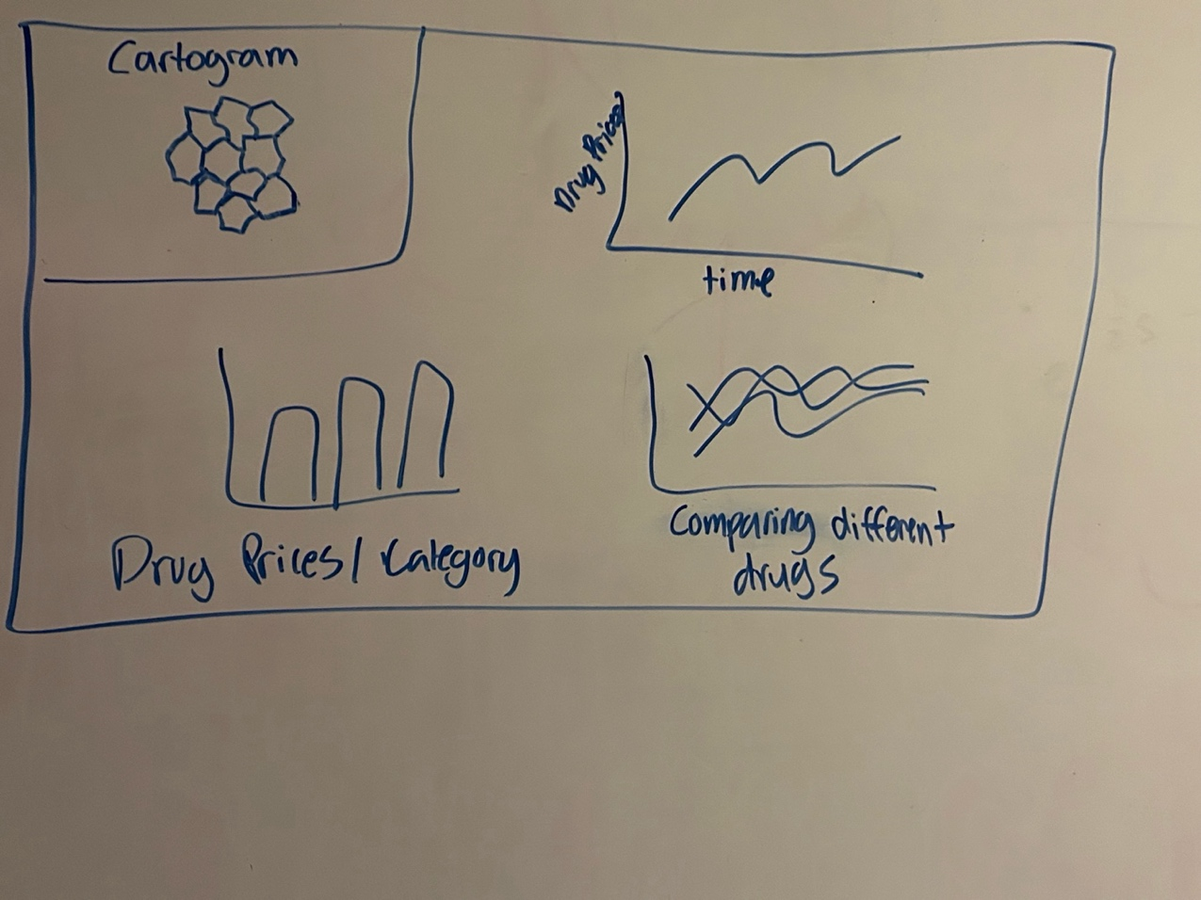

7. PROCESS
03/16/2025 Comments from Coach Wappett
Erin, really great project off to a solid start. I'm wondering if you should narrow your focus to the top 5 or 10 prescription drugs. I also wonder how much they cost in the US versus internationally. I also know that when a drug hits a certain age, a generic version can be created for less. I'm thinking you need R&D cost, actual cost of drug, average insurance cost. I found this dashboard pretty interesting for the state of Virgina: https://public.tableau.com/app/profile/virginiahealthinformation/viz/2023PrescriptionDrugPriceTransparencyReport/2023PrescriptionDrugPriceTransparencyReport
I wonder if Utah has something similar... In any event, this is a big wonder that you'll probably need to narrow as you continue to explore.
03/20/2025 New Data Found
I found a new data set from:
https://data.medicaid.gov/dataset/eec7fbe6-c4c4-5915-b3d0-be5828ef4e9d#data-table
Here is the new data dictionary
Field Name | Description & Notes
Record ID | Constant of “FFSU” or “MCOU” - The FFSU Record ID indicates that the information for this NDC represents a Fee-for-Service Utilization record. The MCOU Record ID indicates that the information for this NDC represents a Managed Care Organization Utilization record. Valid Values: 4Q2009 and earlier = Constant record of FFSU 1Q2010 and beyond = FFSU & MCOU
State Code | State Abbreviation - Two character post office abbreviation for State
NDC | The National Drug Code (NDC) is a numerical code maintained by the FDA that includes the labeler code, product code, and package code. The NDC is an 11-digit code
Labeler Code | NDC #1 - First segment of National Drug Code that identifies the manufacturer, labeler, relabeler, packager, repackager or distributor of the drug.
Product Code | NDC #2 - Second segment of National Drug Code
Package Size | NDC #3 - Third segment of National Drug Code
Year | Calendar year covered by data.
Quarter | Calendar quarter covered by data. Valid values: 1 = January 1 - March 31 2 = April 1 - June 30 3 = July 1 - September 30 4 = October 1 - December 31.
Product FDA List Name | Product Name as appears on FDA listing form (1st 10 characters).
Units Reimbursed | The total number of units (based on Unit Type) of the drug (11-digit NDC level) reimbursed by the state during the period covered. [Numeric 15 positions: 11 whole numbers, decimal (.), 3 decimals] (99999999999.999).
No. of Prescriptions | The number of prescriptions reimbursed (by the Medicaid Program ONLY) to pharmacists for the (11-digit NDC) drug for the period covered. [Numeric 9 whole numbers] (999999999).
Total Amount Reimbursed | The total amount reimbursed by both Medicaid and non-Medicaid entities to pharmacies for the (11-digit NDC) drug in the period covered (two below fields added together). This total is not reduced or affected by Medicaid rebates paid to the state. This amount represents both the Federal and State Reimbursement and is inclusive of dispensing fees. [Numeric 15 positions: 12 whole numbers, decimal (.), 2 decimal places] (999999999999.99).
Medicaid Amount Reimbursed | The amount reimbursed (by the Medicaid Program ONLY) to pharmacies for the (11-digit NDC) drug in the period covered. ([Numeric 13 positions: 10 whole numbers, decimal (.), 2 decimal places] (9999999999.99).
Non-Medicaid Amount Reimbursed | The amount reimbursed (by non-Medicaid entities) to pharmacies for the (11-digit NDC) drug in the period covered. The Non-Medicaid Amount Reimbursed includes any reimbursement amount for which the state is not eligible for Federal Matching Funds. [Numeric 13 positions: 10 whole numbers, decimal (.), 2 decimal places] (9999999999.99)

I think that my new Audience would be Pharmacies, medication manufacturers, or anyone who has a knowledge of medications and wants to take a look at the correlation of states and prescriptions sold/cost.
04/02/2025 Meeting with Coach Wappett
I had a meeting with Coach Wappett today to go over the new data set that I found as well as the dashboard I made for the data. She gave me some great feedback on some things to fix and confirmed that I can continue with my data and dashboard.
04/05/2025 Fixing the Dashboard
I updated my dashboard and made my new charts with my new data so that it can answer my new wonders and thoughts with the data. The screenshots are below:
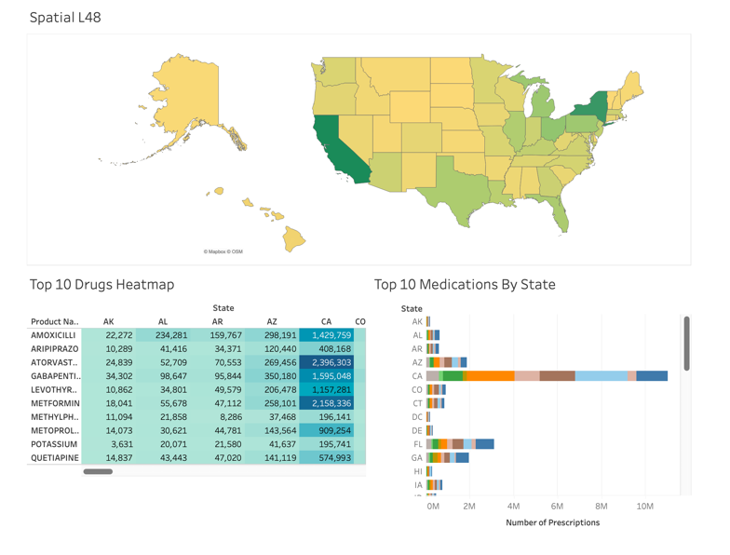
Old:

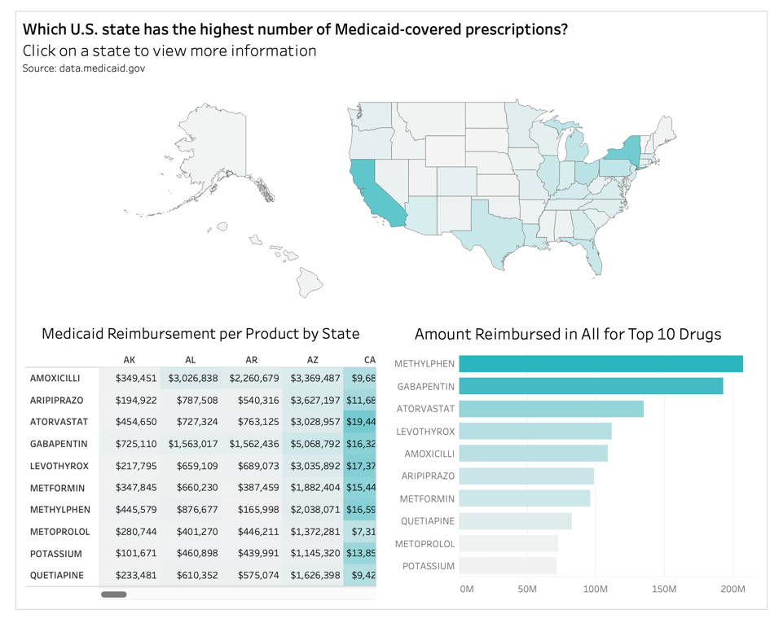
New:

04/09/2025 Feedback from Peers
Gavin Miller:
Good job on the interactive charts you've made! I like the idea of being able to cluster states together to show a broader story. I think it would be interesting to dive into the specific drugs for each state. It's great exploratory data but I feel it's missing some of the "why" in your presentation. Looking at the states and reimbursements make total sense but I think some more analysis could be done for the drugs. Looking at what isn't being reimbursed amongst other states, what are popular products in other states but not the highest reimbursement total. You can choose what you see fit, but I think that would enhance your purpose overall. My only other piece of feedback is the color choice for the map along with the other charts. We can see the Northeast and the other large states have that teal blue but it's really difficult to see anything else on the map so toying around with other colors could help improve that. Great job!
Brock Jessop:
Something strong: the charts look really good and easy to follow and understand. Something that could be improved: I think it would be best if you did a descending sort on the amount reimbursed bar chart, so its really easy to tell which one has the highest amount reimbursed.
What I did to improve:
I looked at my why and thought about changing it but ultimately decided to keep it how it was. I understood the concerns, but felt that it was ok to keep it. I also changed to the bar chart to descending to make it easier to read.
04/15/2025 Final Changes
I made some final changes to my dashboard and finished my executive summary. I was able to take feedback to change a couple things, and better think about what I needed to write in my executive summary.

